SEC Form 3
FORM 3 | UNITED STATES SECURITIES AND EXCHANGE COMMISSION
 | Washington, D.C. 20549
 | Washington, D.C. 20549 |  | OMB APPROVAL
 | INITIAL STATEMENT OF BENEFICIAL OWNERSHIP OF SECURITIES
 | INITIAL STATEMENT OF BENEFICIAL OWNERSHIP OF SECURITIES |  | OMB Number: | 3235-0104
 |  |  | Estimated average burden
 | Filed pursuant to Section 16(a) of the Securities Exchange Act of 1934 |  | hours per response: | 0.5
or Section 30(h) of the Investment Company Act of 1940
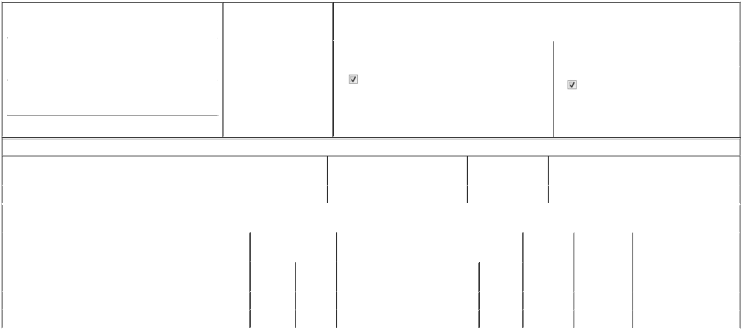

1. Name and Address of Reporting Person* |  |  |  |  |  | 2. Date of Event Requiring
 |  | Fitzgerald Buffum Shannon |  |  |  | Statement (Month/Day/Year)
 |  |  |  |  | 05/20/2026
 |  | (Last) | (First) |  | (Middle)
 |  | 8283 GREENSBORO DRIVE
(Street)
 |  | MCLEAN | VA |  | 22102

3. |  | Issuer Name and Ticker or Trading Symbol
 | Booz Allen Hamilton Holding Corp [ BAH ]
4. |  | Relationship of Reporting Person(s) to Issuer |  |  | 5. | If Amendment, Date of Original Filed (Month/Day/Year)
 | (Check all applicable)
 |  | Director | 10% Owner
 |  | Director |  |  | 6. | Individual or Joint/Group Filing (Check Applicable Line)
 |  | Officer (give title | Other (specify below) |  | 6. | Individual or Joint/Group Filing (Check Applicable Line)
 |  | below) |  |  |  | Form filed by One Reporting Person
 |  | Executive Vice President |  |  |  | Form filed by More than One Reporting Person

(City) (State) (Zip)

Table I - Non-Derivative Securities Beneficially Owned

1. Title of Security (Instr. 4) | 2. Amount of Securities Beneficially | 3. Ownership Form: | 4. Nature of Indirect Beneficial Ownership (Instr. 5)
 | Owned (Instr. 4) | Direct (D) or Indirect
 |  | (I) (Instr. 5)

 | Class A Common Stock |  |  |  | 3,187⁽¹⁾ | D
 |  |  | Table II - Derivative Securities Beneficially Owned
 |  | (e.g., puts, calls, warrants, options, convertible securities)
 | 1. Title of Derivative Security (Instr. 4) |  | 2. Date Exercisable and |  | 3. Title and Amount of Securities Underlying |  | 4. | 5. Ownership | 6. Nature of Indirect Beneficial
 |  |  | Expiration Date |  | Derivative Security (Instr. 4) |  | Conversion | Form: Direct | Ownership (Instr. 5)
 |  |  | (Month/Day/Year) |  |  |  | or Exercise | (D) or Indirect
 |  |  |  |  |  |  | Price of | (I) (Instr. 5)
 |  |  |  |  |  | Amount or | Price of | (I) (Instr. 5)
 |  |  |  |  |  | Amount or | Derivative
 |  |  | Date | Expiration | Title | Number of | Security
 |  |  | Exercisable | Date | Title | Shares
 | Employee Stock Option (right to buy) | (2) |  | 05/20/2030 | Class A Common Stock | 19,359 | 74.59 | D
 | Employee Stock Option (right to buy) | (3) |  | 03/28/2034 | Class A Common Stock | 6,446 | 148.44 | D
 | Explanation of Responses:

- Includes 274 and 804 restricted stock units, issued under the Issuer's 2023 Equity Incentive Plan exempt under Rule 16b-3. Each restricted stock unit represents a contingent right to receive one share of the Issuer's Class A common stock upon vesting. 274 restricted stock units are scheduled to vest and settle on March 31, 2027, subject to the Reporting Person's continued employment. Half of the 804 restricted stock units are scheduled to vest and settle on each of March 31, 2026, and 2027, subject to the Reporting Person's continued employment.

- All options are fully vested and exercisable.

- 2,578 options are fully vested and exercisable. The remaining options vest and become exercisable, subject to the reporting person's continued employment, on March 31, 2027, 2028, and 2029. These options fully vest and become exercisable immediately prior to the effective date of certain change in control events.

Remarks:

By: /s/ Jamie Weatherby, as Attorney-

in-Fact for Shannon Fitzgerald Buffum

** Signature of Reporting Person

05/22/2026

Date

Reminder: Report on a separate line for each class of securities beneficially owned directly or indirectly.

* If the form is filed by more than one reporting person, see Instruction 5 (b)(v).

- Intentional misstatements or omissions of facts constitute Federal Criminal Violations See 18 U.S.C. 1001 and 15 U.S.C. 78ff(a). Note: File three copies of this Form, one of which must be manually signed. If space is insufficient, see Instruction 6 for procedure.
Persons who respond to the collection of information contained in this form are not required to respond unless the form displays a currently valid OMB Number.



